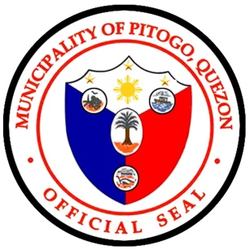
Republic of the Philippines
Province of Quezon
Municipality of Pitogo
-o0o-
BIDS AND AWARDS COMMITTEE
lgubac71717@gmail.com

PROPOSAL FORM
(NEGOTIATED PROCUREMENT SAGIP-SAKA)

Date:

Project Title : | Assistance to Indigent Families – Food Assistance (Rice Subsidy Project) under the Local Government Support Funds Government Equity Fund (LGSF – GEF) FY 2026
Approved Budget for the Contract (ABC) : | Php 4,999,800.00
Identification Number : | PR No. 101-2026-07-410

The Bids and Awards Committee
Municipal Government of Pitogo
A. Mabini St Brgy. Maaliw, Pitogo, Quezon

After having carefully read and accepted the terms and conditions in the Request for Proposal/Offer, We, the undersigned, offer to supply the required goods in conformity with the specifications for the sum stated below:

Item Number | Quantity | Unit of Issue | Item Description | Unit Price | Total Amount
 | 7,692 | Bags | Rice Grains, Well-Milled, 10 kgs./bag  - Variety: Locally – harvested  Denurado/Jasmine or equivalent  - Moisture Content: 12% - 14.5%  - 80/20 ratio of whole versus broken grains – No blending with other varieties/ without any non – rice element (free from sand, glass stones, non – rice plant material)  - No impurities  - No foul odor (free from sour, musty or other abnormal odors)  - Soft, Tasty, and Edible even after five (5) hours after cooking  - Complaint with PNS/BAFS 290: 2019 Standards for well – milled rice  - Locally – sourced from CALABARZON Region  - Packed in Sako bag with printed Bagong Pilipinas logo, and “Bawat Bayan Makikinabang” and LGU Logo

Total Amount in Words: __________________________________________
Total Amount in Figures: Php______________________________________

